**Scripting Task**

1.Create a shell script to print the HTTP error code of guvi.in & print, the success/failure message based on the error code response

2.Given a file, replace all occurrence of the word "give" with "learning" from 5th line till the end in only those lines that contain the word "welcome"

Create a file using touch cmd in linux **#touch scripting.sh** and use vi editor to create a script open the VI edit follow with file name **#vi scripting.sh** once opened edit the file and write the script .

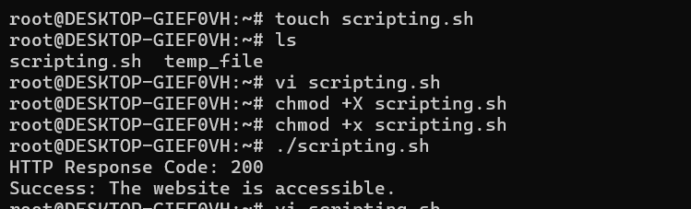

print the HTTP error code of guvi.in & print, the success/failure message based on the error code response type below script . 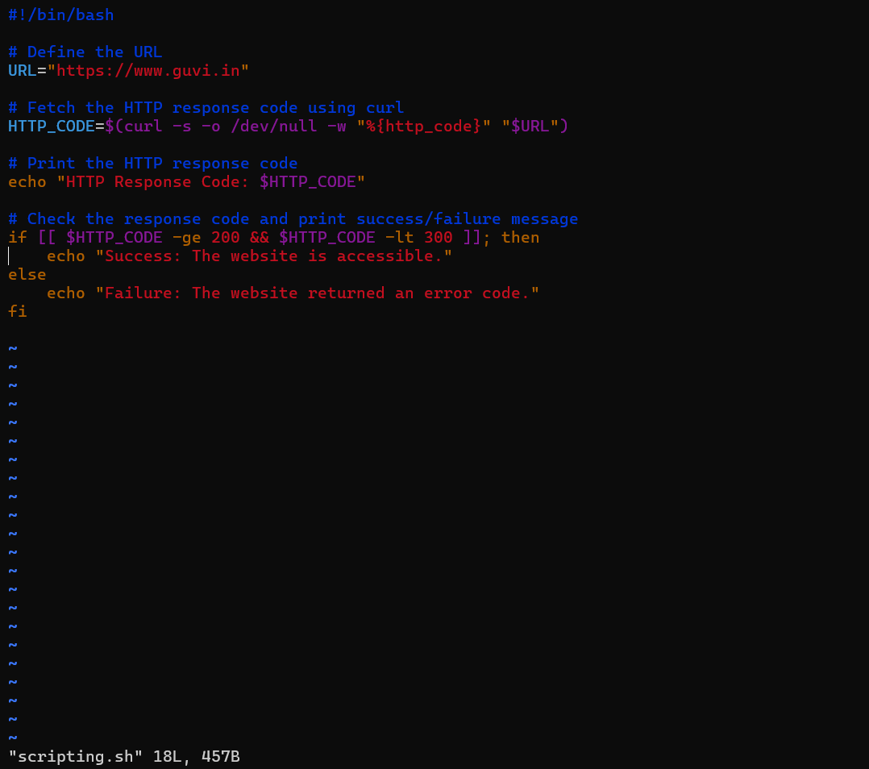

:wq save and exit the script and run it make sure that file permission is enabled to run the script #./ scripting .sh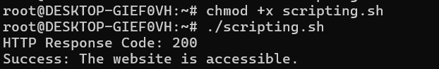

Given a file, replace all occurrence of the word "give" with "learning" from 5th line till the end in only those lines that contain the word "welcome" type as shown below and run it .

